Configuring date and time
Scenario: The FC is unable to process payments. This is sometimes due to the time and date being different on the system and the device. We will set them to the same to fix this error.

- Log into the POS with your PIN.
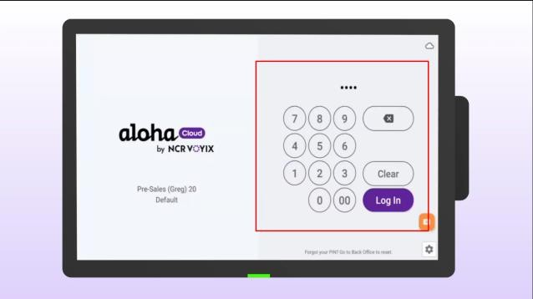
- Click the menu in the top left corner of the screen.
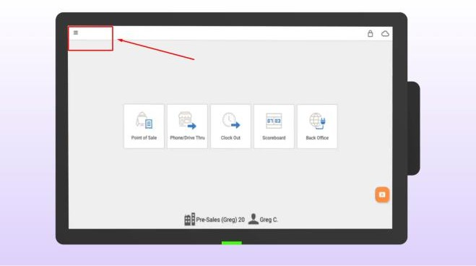
- Select SETTINGS.
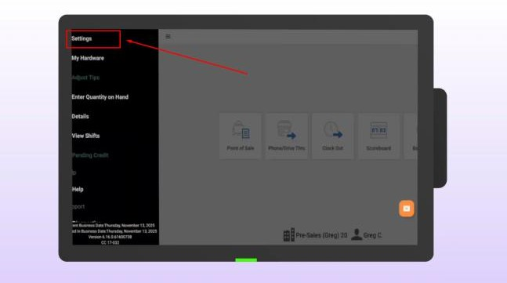

- Scroll to the bottom of the page and tap ANDROID SETTINGS to access the core device settings.
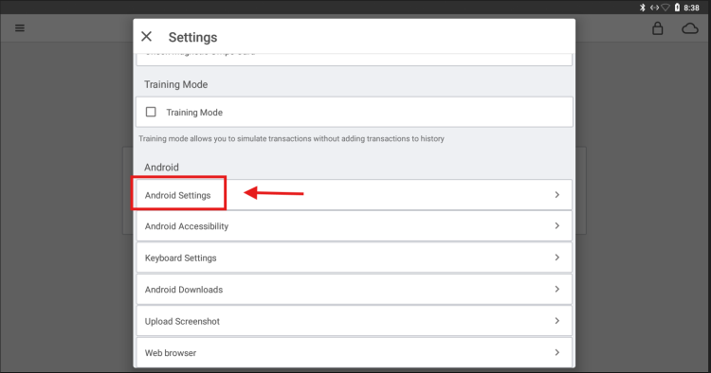
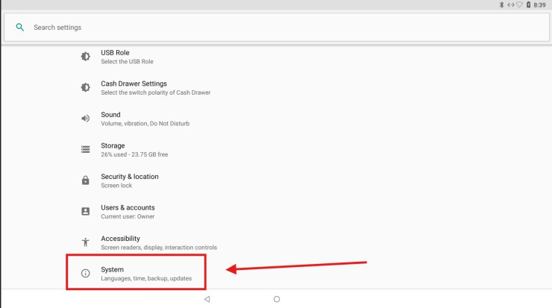
- Scroll down and select SYSTEM.
- Tap DATE AND TIME.
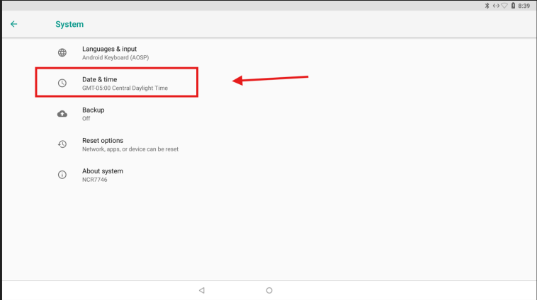

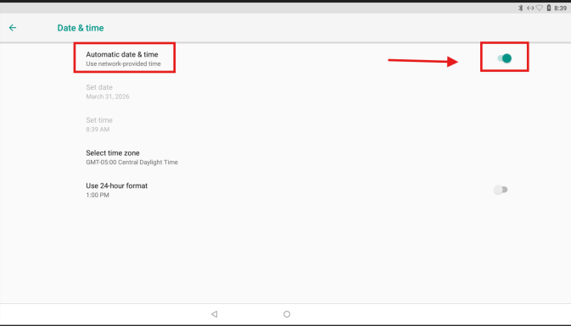
- Turn off the "Automatic time" setting (use network-provided time).
- Set the time manually using the clock interface.
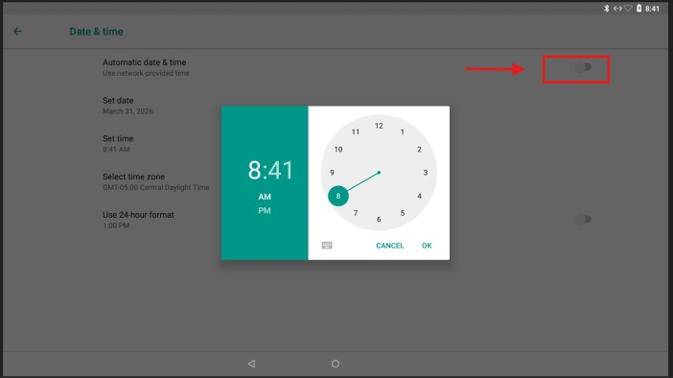
- You can return to the main screen.

